Problem using Chebyshev’s Theorem
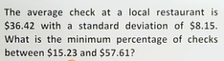

chebyshev’s theorem
Minimum no of checks is between $15.23 and $57.61
Theorem requires the interval we use its symmetric around the mean.
Mean is at the centre of the interval.
Minimum percentage the chebyshev theorem uses cuz it gives u atleast x% is in the interval.
It doesn’t indicate the shape of the distribution I.e it is bell,mountain,symmetric shape distribution.
Chebyshev theorem can be used for any shape distribution.
If you think of chebyshev theorem, first think you should try to do is find k.
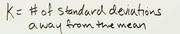

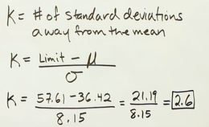
for lower limit we got -2.6
we need almost the same number

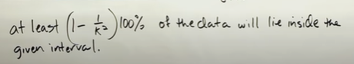

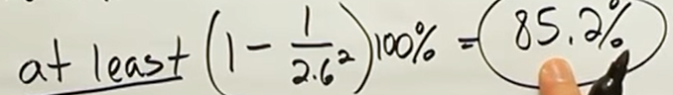

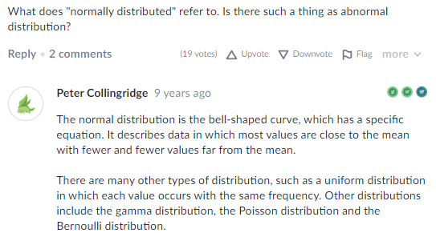
z-scores


